SE IT-A roll no-37

1)Java program to display default value of all primitive data type

import java.util.\*;

class valueask

{

static int i;

static String s;

static char g;

static long m;

static byte b;

static short sn;

static float f;

static double d;

static boolean bo;

public static void main(String args[])

{

System.out.println("int :"+i);

System.out.println("string :"+s);

System.out.println("char :"+g);

System.out.println("long :"+m);

System.out.println("byte :"+b);

System.out.println("short :"+sn);

System.out.println("float :"+f);

System.out.println("double :"+d);

System.out.println("boolean:"+bo);

}

}

Output:

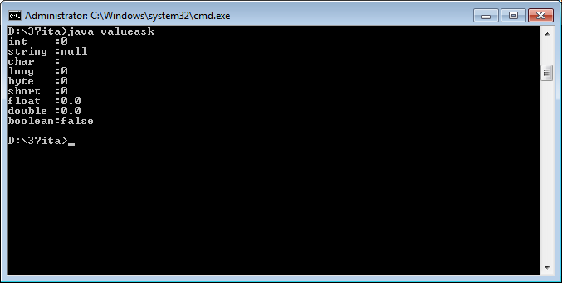

2)java program to display the roots of quadratic equation

import java.util.\*;

class quadratic

{

public static void main(String args[])

{

Scanner sc=new Scanner(System.in);

System.out.println("enter value of a,b,c");

int a=sc.nextInt();

int b=sc.nextInt();

int c=sc.nextInt();

double r1=0.0,r2=0.0,d;

d=(b\*b)-(4\*a\*c);

if(d>0)

{

r1=(-b+Math.sqrt(d))/(2\*a);

r2=(-b-Math.sqrt(d))/(2\*a);

System.out.println("the first root is:"+r1);

System.out.println("the second root is:"+r2);

}

else if(d==0)

{

r1=(-b)/(2\*a);

System.out.println("both roots are equal that is:"+r1);

}

else

{

System.out.println("no solution");

}

}

}

